**Research & Write Test Cases**

|  |  |  |  |  |  |
| --- | --- | --- | --- | --- | --- |
| Test ID | User story | Scenario | Preconditions | steps | Expected result |
| |  | | --- | | **TC-01** |  |  | | --- | |  | | |  |  |  | | --- | --- | --- | | |  | | --- | | **US-01 – Event Submission** |  |  | | --- | |  | | | |  | | --- | | Organizer creates an event with valid info . |  |  | | --- | |  | | |  | | --- | | Organizer account verified & logged in |  |  | | --- | |  | | |  | | --- | | 1) Click **Create Event**  2) Fill all required fields  3) Click **Submit** |  |  | | --- | |  | | |  | | --- | | Event status becomes **Submitted**; appears in **Admin Review**; organizer sees success message |  |  | | --- | |  | |
| |  | | --- | | **TC-02** |  |  | | --- | |  | | |  |  |  | | --- | --- | --- | | |  | | --- | | **US-02 – Manage Events (Edit)** |  |  | | --- | |  | | | |  | | --- | | Organizer edits a **Draft/Submitted** event and saves |  |  | | --- | |  | | |  |  |  | | --- | --- | --- | | |  | | --- | | Organizer has an event in **Draft** (or **Submitted**, not Approved) |  |  | | --- | |  | |  |  | | --- | |  | | |  |  |  | | --- | --- | --- | | |  | | --- | | 1) Open **My Events**  2) Open event  3) Click **Edit**  4) Change Title  5) **Save** |  |  | | --- | |  | | | |  | | --- | | Changes saved; event keeps its state (Draft/Submitted); updated title shown in list/details |  |  | | --- | |  | |
| |  | | --- | | **TC-03** |  |  | | --- | |  | | |  |  |  | | --- | --- | --- | | |  | | --- | | **US-02 – Manage Events (Delete)** |  |  | | --- | |  | |  |  | | --- | |  | | |  |  |  | | --- | --- | --- | | |  | | --- | | Organizer deletes a **Draft** event with confirmation |  |  | | --- | |  | |  |  | | --- | |  | | |  |  |  | | --- | --- | --- | | |  | | --- | | Organizer has a **Draft** event |  |  | | --- | |  | |  |  | | --- | |  | | |  | | --- | | 1) Open **My Events** 2) Select Draft event  3) Click **Delete**  4) Confirm |  |  | | --- | |  | | |  | | --- | | Event removed from list; confirmation message displayed; no longer searchable |  |  | | --- | |  | |
| |  | | --- | | **TC-04** |  |  | | --- | |  | | |  | | --- | | **US-03 – Organizer Profile** |  |  | | --- | |  | | |  | | --- | | Organizer updates profile and requests verification |  |  | | --- | |  | | |  |  |  | | --- | --- | --- | | |  | | --- | | Organizer logged in; profile not verified |  |  | | --- | |  | |  |  | | --- | |  | | |  | | --- | | 1) Open **Profile**  2) Upload logo  3) Enter website/contact  4) Click **Request Verification** |  |  | | --- | |  | | |  | | --- | | Profile saved; status = **Pending Verification**; organizer sees “Submitted for review” message |  |  | | --- | |  | |
| |  | | --- | | **TC-05** |  |  | | --- | |  | | |  | | --- | | **US-04 – Browse Events** |  |  | | --- | |  | | |  | | --- | | Attendee filters by **Category=Family** and **Date=Weekend** |  |  | | --- | |  | | |  | | --- | | ≥3 events exist with mixed categories/dates |  |  | | --- | |  | | |  | | --- | | 1) Open **Events**  2) Set filters (Family + Weekend)  3) Click **Apply** |  |  | | --- | |  | | |  | | --- | | Only matching events listed; count updates; no unrelated events shown |  |  | | --- | |  | |
| |  | | --- | | **TC-06** |  |  | | --- | |  | | |  | | --- | | **US-05 – Event Details** |  |  | | --- | |  | | |  | | --- | | Attendee views event details page (map/time/contact visible) |  |  | | --- | |  | | |  | | --- | | Event has location, time, contact info |  |  | | --- | |  | | |  | | --- | | 1) From list, open the event card  2) View details |  |  | | --- | |  | | |  | | --- | | Page shows title, description, images, **map**, **local time**, and **contact info** correctly |  |  | | --- | |  | |
| |  | | --- | | **TC-07** |  |  | | --- | |  | | |  | | --- | | **US-06 – Save & Share** |  |  | | --- | |  | | |  | | --- | | Attendee adds event to **Google Calendar** successfully |  |  | | --- | |  | | |  | | --- | | Event is public; user in browser session |  |  | | --- | |  | | |  | | --- | | 1) Open event details  2) Click **Add to Calendar**  3) Choose **Google** 4) Confirm |  |  | | --- | |  | | |  | | --- | | Calendar entry created with correct title, start/end time, and venue |  |  | | --- | |  | |
| |  | | --- | | **TC-08** |  |  | | --- | |  | | |  | | --- | | **US-07 – Review Submissions** |  |  | | --- | |  | | |  | | --- | | Admin **approves** a submitted event with a note |  |  | | --- | |  | | |  | | --- | | At least one event in **Submitted** state |  |  | | --- | |  | | |  | | --- | | 1) Login as **Admin** 2) Open **Review Queue**  3) Open event  4) Click **Approve**  5) Add note  6) Confirm |  |  | | --- | |  | | |  | | --- | | Status = **Approved**; event becomes public; organizer notified with the note |  |  | | --- | |  | |
| |  | | --- | | **TC-09** |  |  | | --- | |  | | |  | | --- | | **US-08 – Content Moderation** |  |  | | --- | |  | | |  | | --- | | Admin removes an **inappropriate** public event |  |  | | --- | |  | | |  | | --- | | Event is public and flagged as inappropriate |  |  | | --- | |  | | |  | | --- | | 1) Admin opens event  2) Click **Remove/Unpublish** 3) Enter reason  4) Confirm |  |  | | --- | |  | | |  | | --- | | Event hidden/unpublished; reason logged; no longer visible to attendees |  |  | | --- | |  | |
| |  | | --- | | **TC-10** |  |  | | --- | |  | | |  | | --- | | **US-09 – Organizer Verification** |  |  | | --- | |  | | |  | | --- | | Admin verifies organizer after document check (ABN/community proof) |  |  | | --- | |  | | |  | | --- | | Organizer submitted verification; docs provided |  |  | | --- | |  | | |  | | --- | | 1) Admin opens **Organizer Verification** queue 2) Review docs  3) Click **Verify** |  |  | | --- | |  | | Organizer marked **Verified**; organizer notified; verified badge appears on profile/events |
|  |  |  |  |  |  |

**Installed Selenium on Visual Studio**

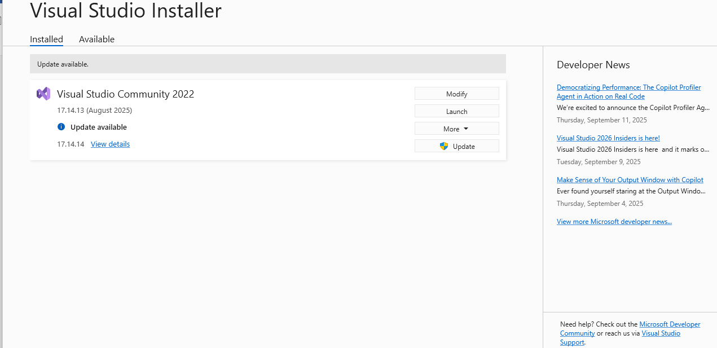

Link Video tut:

[**https://www.youtube.com/watch?v=jyxrqFg4QnI**](https://www.youtube.com/watch?v=jyxrqFg4QnI)

Sample test:

using OpenQA.Selenium;

using OpenQA.Selenium.Chrome;

namespace DotnetSelenium

{

public class Tests

{

[SetUp]

public void Setup()

{

}

[Test]

public void Test1()

{

//Sudo code for setting up selenium

//1. create a new instance of Selenium Web Driver

IWebDriver driver = new ChromeDriver();

// 2. Navigate to the URL

driver.Navigate().GoToUrl("https://www.google.com/");

// 2a. Maximize the browser window

driver.Manage().Window.Maximize();

//3. Find the element

IWebElement webElement = driver.FindElement(By.Name("q"));

// 4.Type in the element

webElement.SendKeys("Selenium");

// 5. Click on the element

webElement.SendKeys(Keys.Return);

}

}

}

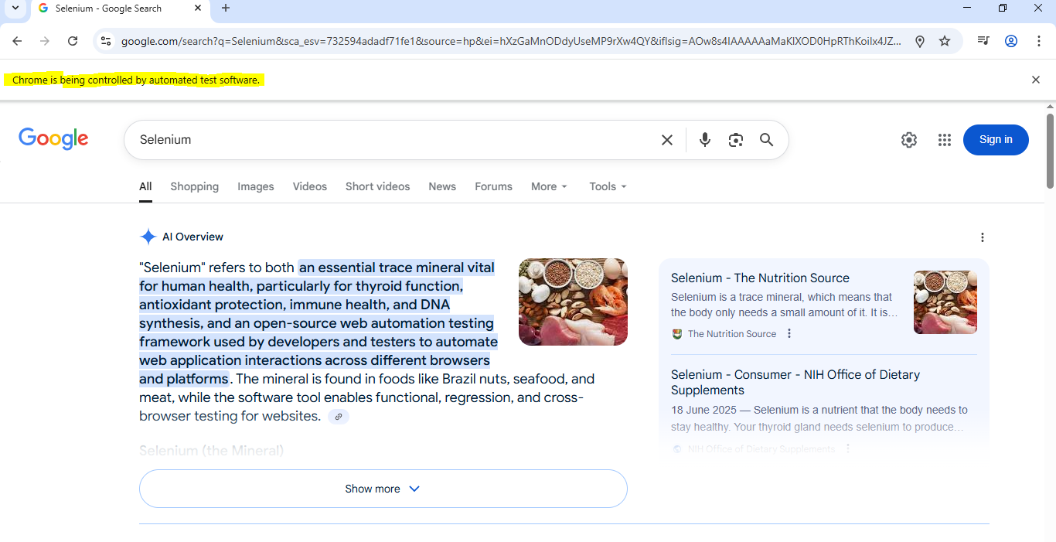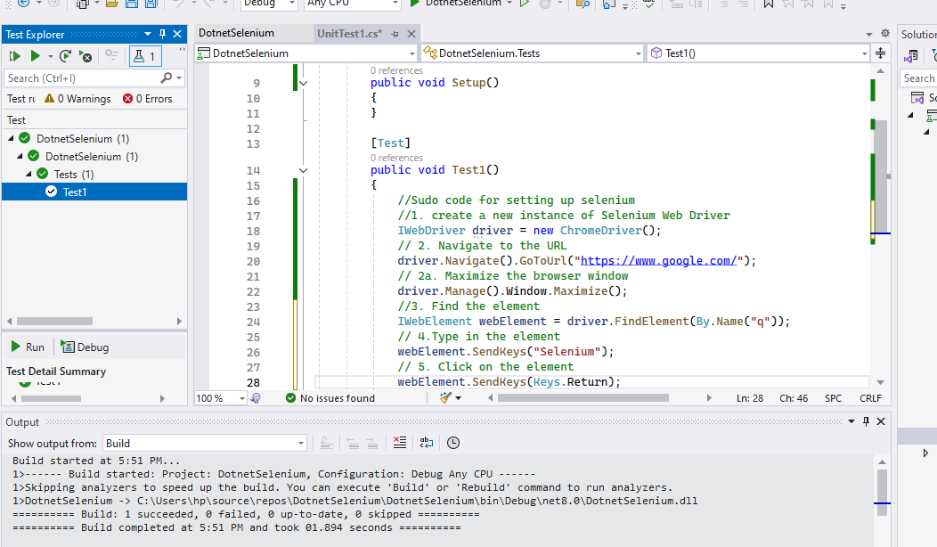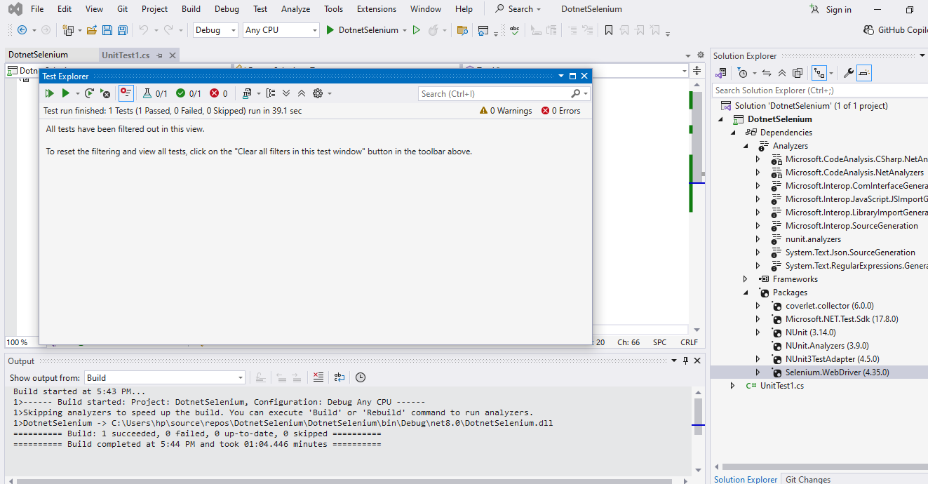

**Identify Testing Tools**

**Postman**

* What it is: A tool to check if APIs (the “back-end connections”) are working.
* What it does: You can send requests like “give me all events” and see the reply from the system.
* Simple example: Type the event API link in Postman → click Send → it shows event details in JSON format.

**Selenium**

* What it is: A tool to control a web browser automatically.
* What it does: You write small scripts that click buttons, type in forms, and check results.
* Simple example: Selenium opens Chrome, logs in as an organizer, fills out the event form, clicks submit, and checks that the event was created.

**JMeter**

* What it is: A tool to test performance (speed under heavy load).
* What it does: Pretends to be many users using the system at the same time.
* Simple example: You set 200 fake users in JMeter → all apply filters at once → JMeter measures how fast the system responds.

**Fiddler**

* What it is: A tool to watch and record network traffic (the messages going between your computer and the server).
* What it does: Helps you see what’s sent and what’s received.
* Simple example: You click “Register for Event” → Fiddler shows the exact request your browser sent and the server’s reply.

**Cypress**

* What it is: A modern tool for testing websites from start to finish.
* What it does: Runs in the browser and checks that pages, buttons, and flows work correctly.
* Simple example: Cypress opens your site, applies “Family Weekend” filter, and checks that only Family events show in the list.

**Manual vs Automated Testing**

Manual Testing

* The tester checks the system by hand: clicking buttons, filling forms, and observing results.
* *Example in your app:* Open the “Create Event” page, type in event details, and check if the event is saved.
* *Good for:* new features, exploratory testing, and quick checks.
* *Limitations:* slow, can miss things if repeated many times.

Automated Testing

* Tests are written as scripts or run in tools to repeat actions automatically.
* *Example in your app:* Use Selenium to automatically log in as an organizer, fill the event form, and submit it.
* *Good for:* regression testing, repeated checks, continuous integration.
* *Limitations:* setup takes more time, needs technical skills.

**2) Functional vs Non-Functional Testing**

Functional Testing

* Checks what the system does (features).
* *Example:* Verify an attendee can filter events by “Family + Weekend” and see the right list.
* *Goal:* Make sure each user story requirement works correctly.

Non-Functional Testing

* Checks how the system works (quality, performance, security).
* *Performance Example:* Test if the system can show event results quickly when 100 users search at the same time.
* *Security Example:* Test if only admins can approve or delete events.
* *Usability Example:* Check if the interface is simple and easy to use for attendees.

**3) Core Testing Types**

Smoke Testing

* Quick test to see if the system’s “main parts” are working.
* *Example:* Can organizers create events? Can attendees browse events? If these fail, no need to continue.

Sanity Testing

* Focused check after a small change or bug fix.
* *Example:* Developer fixes an error in “Save Event to Calendar”. You test just that part to confirm it’s fixed.

Regression Testing

* After new features are added, check that old features still work.
* *Example:* After adding “Share Event” feature, test again that “Browse Events” and “Event Details” still work.

User Acceptance Testing (UAT)

* Real users test the system in real scenarios before release.
* *Example:* Ask students or community members to use the app, browse events, and give feedback if it matches their needs.

Unit Testing

* Test one small piece of code at a time.
* Example: check if the date field only accepts future dates.
* *Goal:* Make sure each small function works correctly by itself.

Integration Testing

* Test how two or more parts work together.
* Example: when an organizer submits the event form the data goes into the database and then shows in the “My Events” list.
* *Goal:* Make sure connected parts of the system talk to each other properly.